

**Name-Ritik Kumar**

**Batch-4 (DevOps)**

**Roll No- R2142211330**

**Sap Id-500097106**

**Lab Experiment 3: Docker Volume**

**Steps:**

**Step 1: Create a Docker Volume**

Open a terminal on machine.

Run the following command to create a Docker volume named "my_volume":

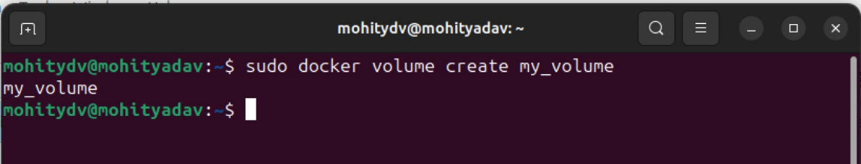

Step 2: Launch Containers with the Volume

Run a container using the volume you created:

docker run -it --name container1 -v my_volume:/app/data nginx

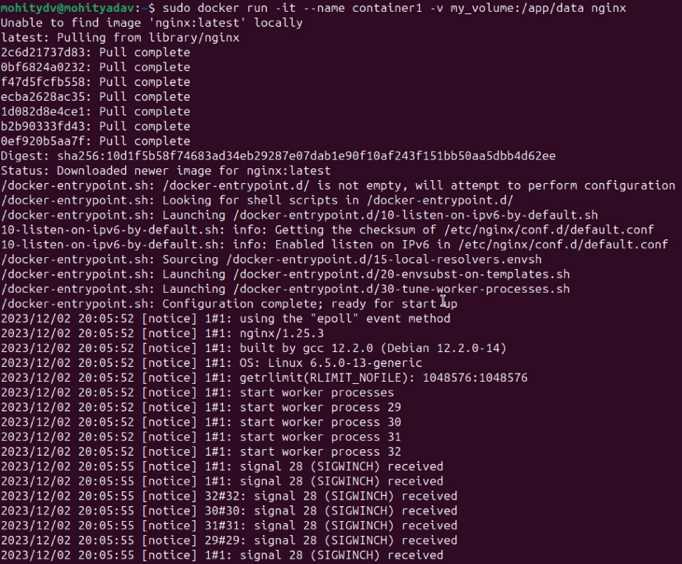

Enter the container to observe the volume and create a file inside it:

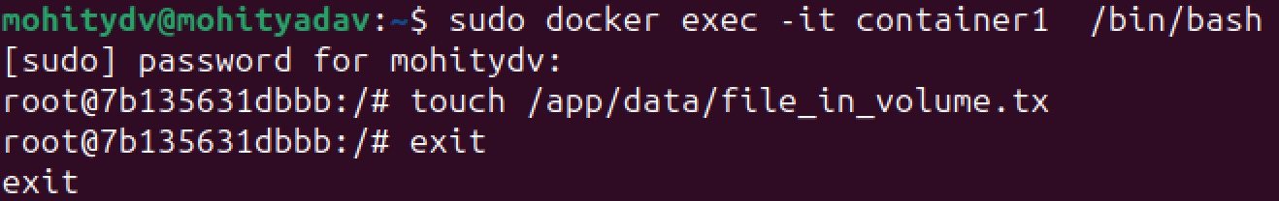

Run a second container, using the same volume, to verify data persistence:

docker run -it --name container2 -v my_volume:/app/data nginx

Enter the second container and check if the file exists:

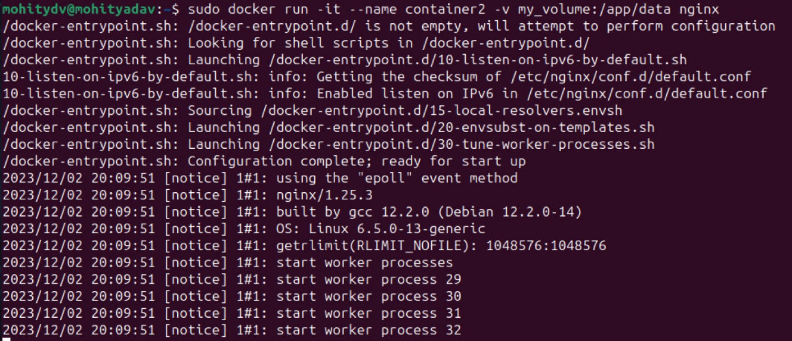

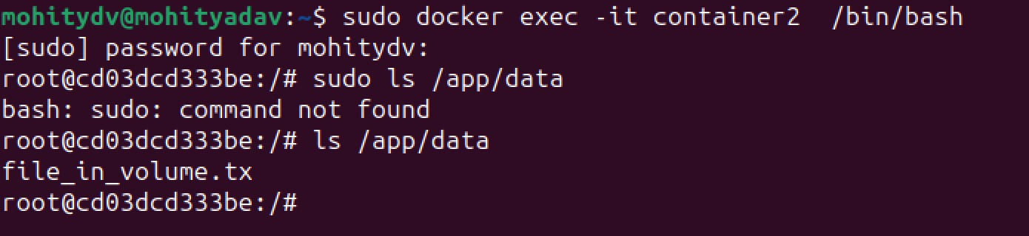

Step 3: Cleanup

Stop and remove the containers:

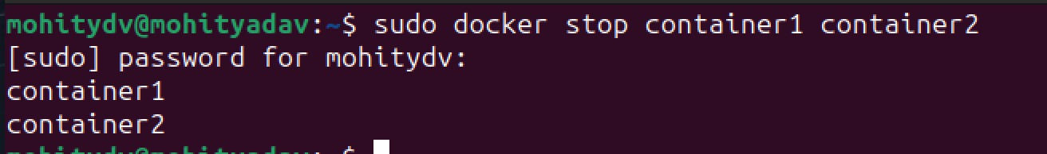

Remove the volume:

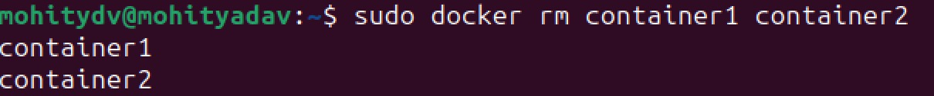

**Conclusion:**

In this experiment, you learned how to create a Docker volume, associate it with containers, and observed how data persisted between different container instances. Docker volumes are essential for maintaining data integrity, sharing data between containers, and ensuring data persistence even when containers are removed or replaced. This skill is crucial for managing stateful applications and databases within a Dockerized environment.